CREATE TABLE

create table empl(emp_name varchar(30),emp_id number,basic_pay number,con_pay number,tax number,net_sal number);

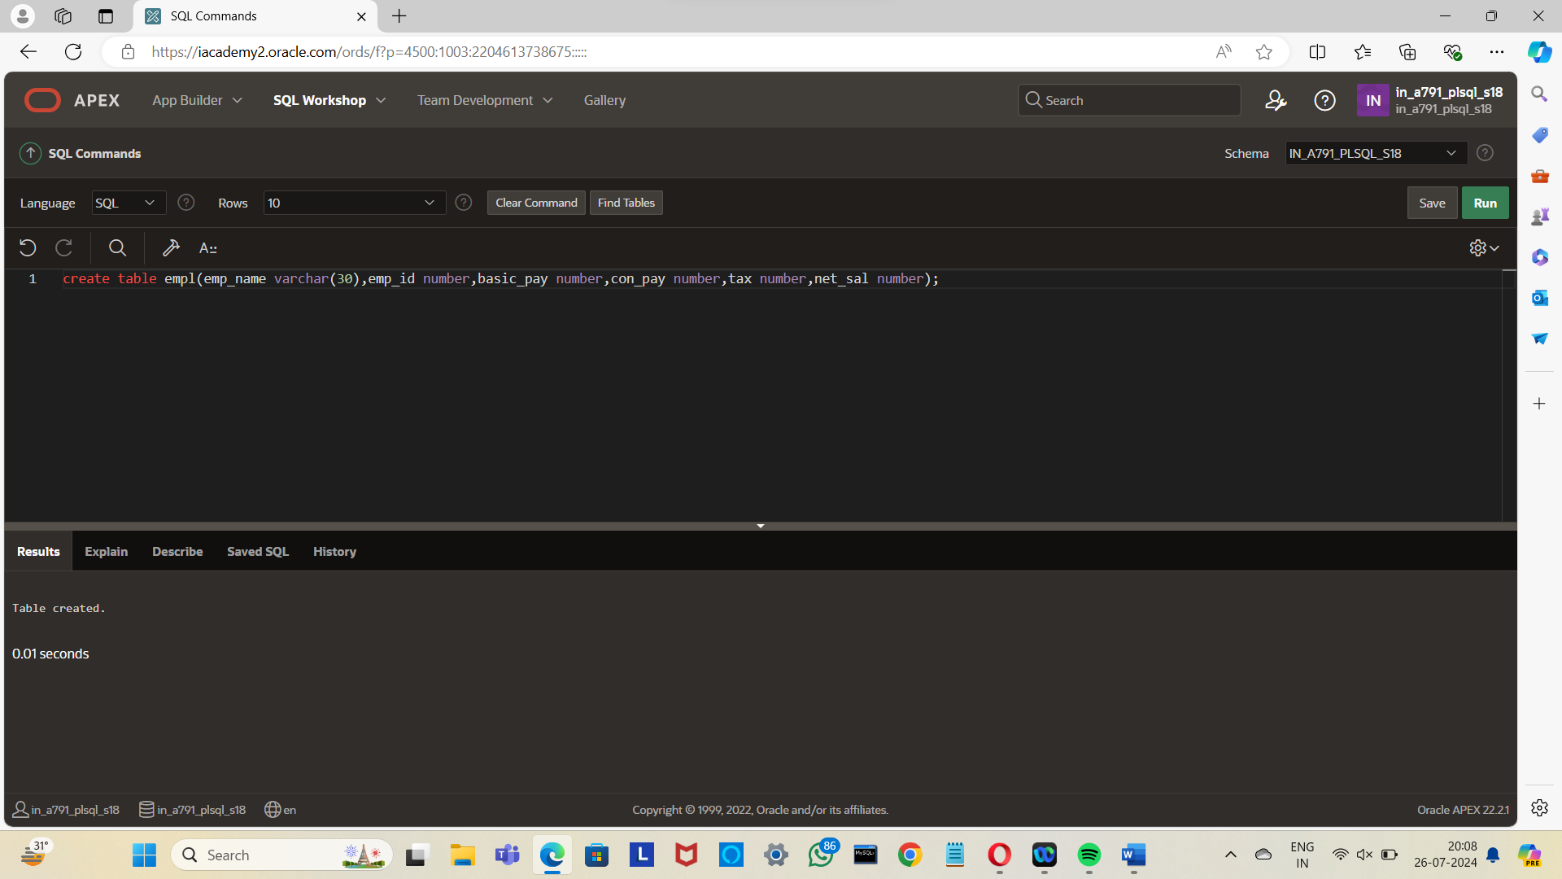

INSERTING VALUES

insert into empl (emp_name,emp_id,basic_pay) values ('aishu',100,30000);

insert into empl (emp_name,emp_id,basic_pay) values ('keerthi',101,30000);

insert into empl (emp_name,emp_id,basic_pay) values ('deepka',103,40000);

insert into empl (emp_name,emp_id,basic_pay) values ('tripura',104,50000);

insert into empl (emp_name,emp_id,basic_pay) values ('deekshi',105,55000);

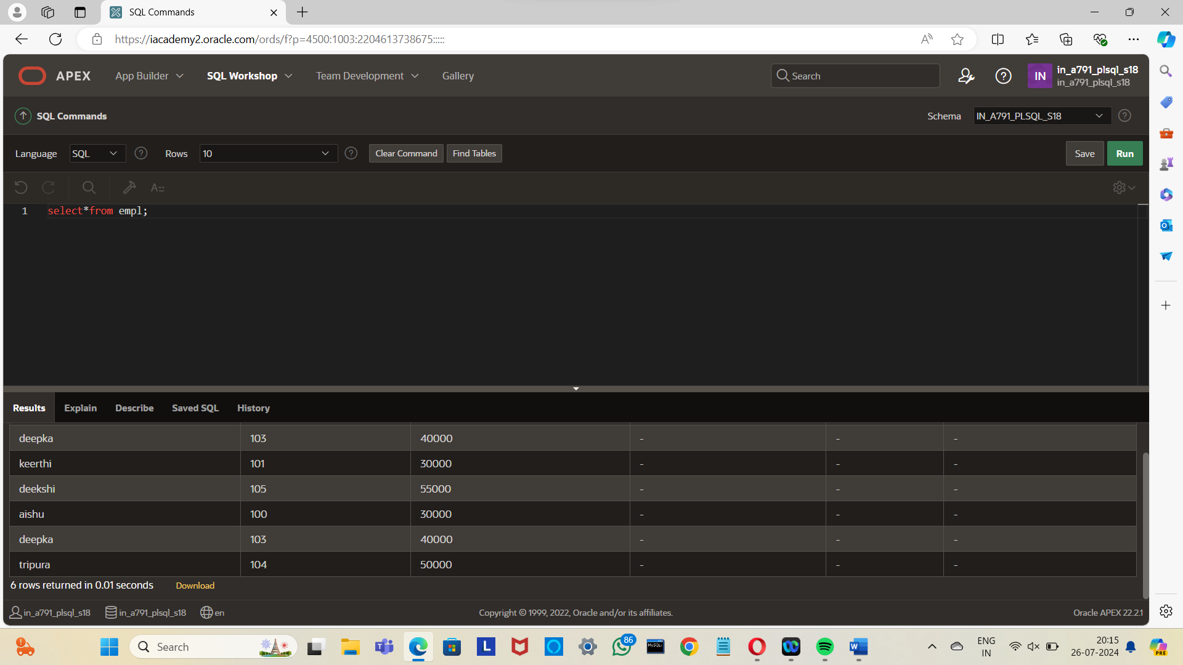

DECLARE CURSOR

DECLARE

CURSOR cempl IS SELECT * FROM empl;

BEGIN

FOR e IN cempl LOOP

IF e.basic_pay = 30000 THEN

UPDATE empl

SET tax = 0.1 * e.basic_pay

WHERE emp_id = e.emp_id;

ELSIF e.basic_pay > 30000 THEN

UPDATE empl

SET tax = 0.2 * e.basic_pay

WHERE emp_id = e.emp_id;

END IF;

END LOOP;

END;

/

